Audio Module
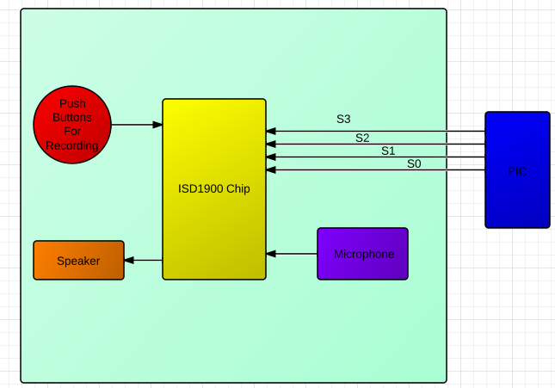
The audio block takes four inputs from the PIC, which correspond to four different sounds that can be played. These sounds are stored via a switch on the record/playback pin. When this pin is grounded, a high input on any of the four pins will cause a sound to be recorded at that position. After all of the sounds have been recorded, we can flip the switch back to playback mode. The block can then be connected to the PIC on the Shuriken, at which point it will function correctly, outputting corresponding sounds when each pin is pulled high.
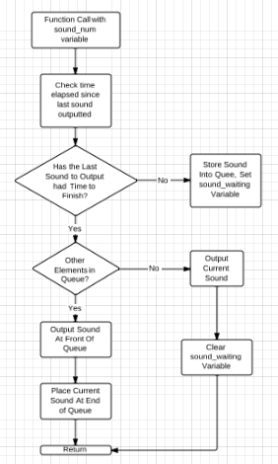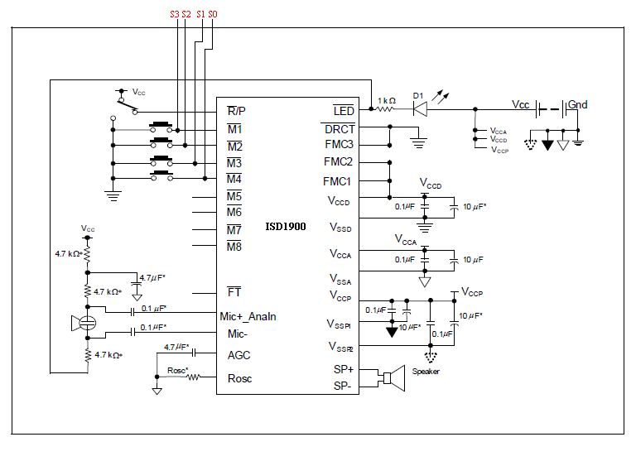
This schematic is a modification of the typical application circuit given in the ISD1900 datasheet
II Alternative Approaches

ISD1700
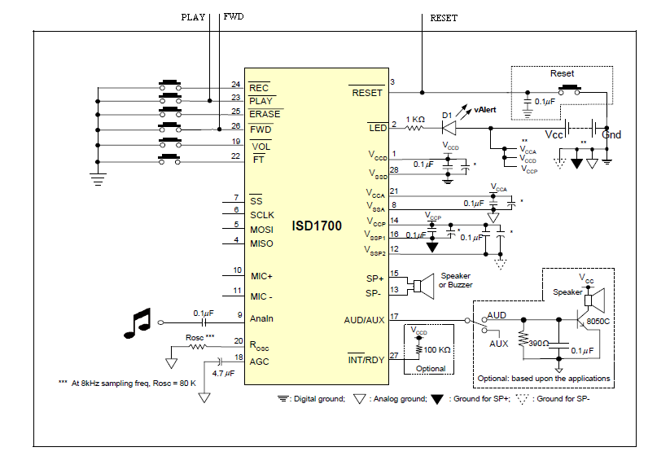

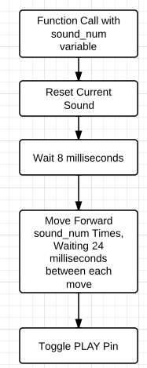
The main drawback of this method is the extreme amount of waiting required to output a sound. Since we are using the main PIC, which is constantly having to poll multiple sources, we are unable to simply busy wait as this would cause us to possibly miss input from the accelerometer. Also, there are no timer interrupts available to allow us to return to this point after waiting.
1 bit sound
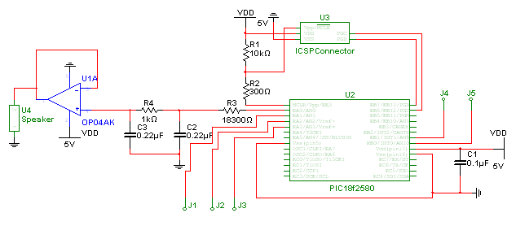
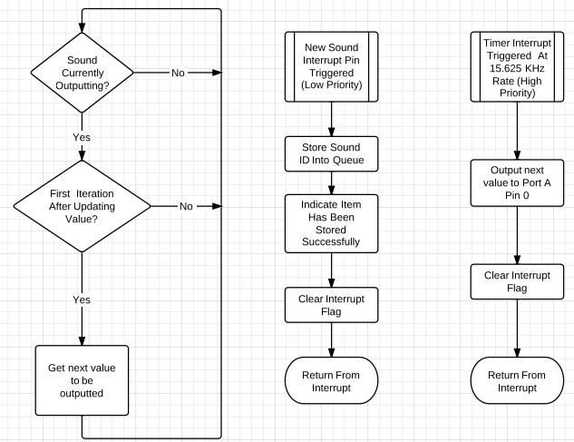
This was a viable option; however, due to the difficulty in justifying an extra PIC on the board, I was forced to go with the audio chip alternative. Another issue that will not be encountered with our number one choice is the fact that there will be no need for an external amplifier. One issue that may have been encountered using this output was the audio quality was perhaps a little low when outputted on headphones. If this were to remain a problem when amplified, I could have slightly changed the algorithm in order to improve the accuracy.

PCM
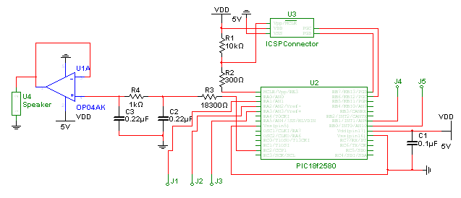
Pulse Width Modulation was also an attractive alternative which fell out of favor mainly due to the necessity of an additional slave PIC, in addition to the need for an amplifier chip. The major complication involved with using PWM is the need for an external EEPROM chip, along with the additional PIC. However, it did have the added bonus of some potential clarity advantages over 1 bit sound.

III Data Sources
Type of datasource | Title, URL, etc. | Using in Protoype?
Datasheet for UA471 Amplifier | http://www.datasheetcatalog.org/datasheet/SGSThomsonMicroelectronics/mXssuwx.pdf | No
Datasheet for NJM2149DAmplifier | http://www.mouser.com/ProductDetail/NJR/NJM2149M/?qs=sGAEpiMZZMtxdzBvM0rKcWwaYVJbKtZqItU0%2fUBeCCE%3d | No
Datasheet for LM386 | http://www.national.com/ds/LM/LM386.pdf | No
In the event that an amplifier was needed, I would have preferred to use the NJM2149. My reasoning for using the NJM2149 over the UA471 was mainly due to the low power consumption of the UA471 at 5 volts. In order to properly operate the speaker I have chosen, I will need to have a power usage over 200 mW at five volts. The main disadvantage of the LM386 is the fact that it has a built in gain of 20. In order to overcome this, I would need to add additional circuitry to remove this gain.

Website | http://www.enide.net/webcms/index.php?page=pcm2pwm | No
Website | http://www.romanblack.com/btc_alg.htm | No
Website | http://www.sparkfun.com/datasheets/BreakoutBoards/SOMO-14D-DS-rev3.pdf | No
My reasoning for not using PCM, or Pulse Code Modulation, is the extreme amount of memory it will take up. Because of this large amount of memory, I would need to purchase and interface with an additional EEPROM chip. However, with one bit sound, I need only one digital output pin, and can store eight values in the space required by one value for PCM. The major drawback of the breakout board was the price, which was much more than that of a PIC.

Datasheet for ISD1900 | http://www.nuvoton.com/hq/enu/ProductAndSales/ProductLines/ConsumerElectronicsIC/ISDVoiceIC/ISDChipCorder/Documents/ISD1900.pdf |  | Yes
Datasheet for ISD1700 | http://www.elexp.com/a_data/ISD1700.pdf |  | No
These are the two chips which I considered that would allow me to avoid using a slave PIC. Ultimately, these were both attractive options compared to the complexity of using the PIC, and with their lower price when considering that they combined storage and an amplifier all in one package, they were obviously the way to go.
Datasheet for PIC18F2580 | http://ww1.microchip.com/downloads/en/DeviceDoc/39637d.pdf |  | No
Datasheet for PIC18F25J10 | http://ww1.microchip.com/downloads/en/DeviceDoc/39682E.pdf |  | No
Datasheet for PIC18F2450 | http://ww1.microchip.com/downloads/en/DeviceDoc/39760d.pdf |  | No
The decision to use the PIC18F2580 in the slave versions came down to two factors: the memory required in order to store the number of sounds necessary was hard to find, and power. The PIC18F25J10 met the memory storage requirements; however, it ran off of 3.3 V. The PIC18F2450 ran off of the correct power amount, however, it did not have enough memory to be used for this application. Another advantage of using the PIC18F2580 is the fact that I am already familiar with setting it up and the interrupt flags which it uses, from my experimentation and the headband.

Datasheet for  254-DS108-RO |  | http://www.mouser.com/catalog/specsheets/KT-400533.pdf | No
Datasheet for 25SP016 |  | http://www.mouser.com/catalog/specsheets/KT-400044.pdf | No
Datasheet for 254-PS605-RO |  | http://www.mouser.com/catalog/specsheets/KT-400259.pdf | No
Datasheet for 254-DS208-RO |  | http://www.mouser.com/catalog/specsheets/KT-400346.pdf | Yes
I decided to go with the 254-DS208-RO based on two factors, the size, at 20 mm, was smaller than all of the other speakers. Additionally, its ability to withstand voltages above 670 mW in the event that this were to occur also was a nice feature to have.

TA Scoring Sheet

Student Name: ________________________________________

TA Name: ________________________________________

Due Date: _________________________________________

Date Demonstrated: _________________________________

Rating | Score | Complete | Engineering Judgment | Datasheet | Simulation / Code Model | Understanding
Master | 100% | Research is complete and convincing. Valid sources of information used. | Knows which parts of project are constrained and which are open to design. Chooses best approach from multiple possibilities based on technical reasons. | Datasheet (info. from previous page) is complete and correct. | Simulation provides guidance on approach. Understands system inputs and outputs. | Thorough understanding of the design and shows insight from research and simulation.
Journeyman | 80% | Research is sufficient but not complete. Some question about sources of information. | Some lack of clarity on freedom of choice vs. constraints.  Multiple approaches considered. Judgments based on effort or knowledge rather than technical reasons. | Some information missing from datasheet, but it is correct. | Simulation provides guidance on approach. Some lack of clarity on inputs/outputs of their block. | Understands their design enough to complete but not improve work.
Apprentice | 60% | Research is spotty or incomplete. Serious questions about the validity of sources. | Little understanding of constraints vs. choices available to them. Multiple approaches considered. No valid basis for choosing one design over another. | Datasheet has several major items missing, and/or some minor errors. | Simulation incomplete and may lead to wrong approach. Inputs/outputs not clearly defined. | Does not fully understand how their design works. Significant gaps of knowledge.
Not acceptable | 0% | Research not done, incorrect, or incomplete. | Multiple approaches not considered. | Datasheet is significantly incomplete or incorrect. | Simulation provides no guidance. Can’t identify inputs/outputs. | Lack of understanding. Ignorance risks team's project or poses safety hazard.

Overall Score: ______ / 100 Pass / Fail

Comments:

